

VILNIUS UNIVERSITY
ŠIAULIAI ACADEMY
BACHELOR PROGRAMME SOFTWARE ENGINEERING

Service-oriented Architecture
Lab work No. 3

Group members: Hanna Asiadouskaya
Leacture: Vaidas Giedrimas

Šiauliai, 2024

The REST webservice works totally fine with localhost.
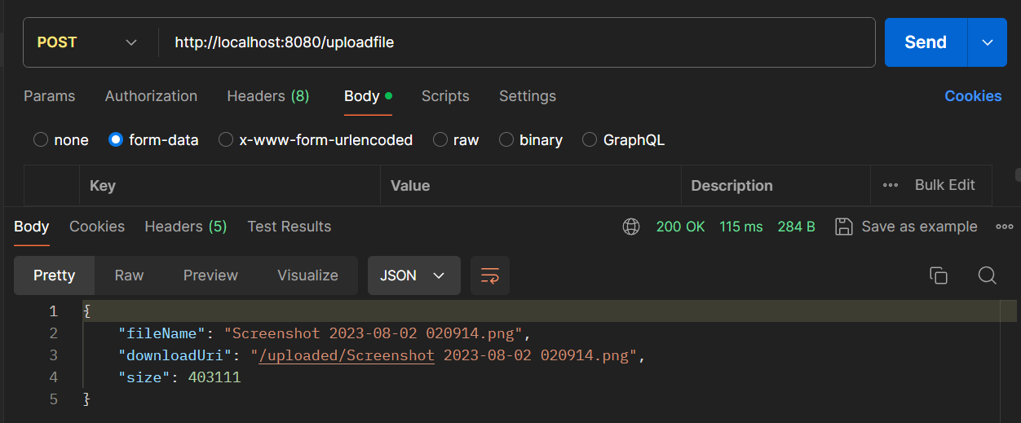
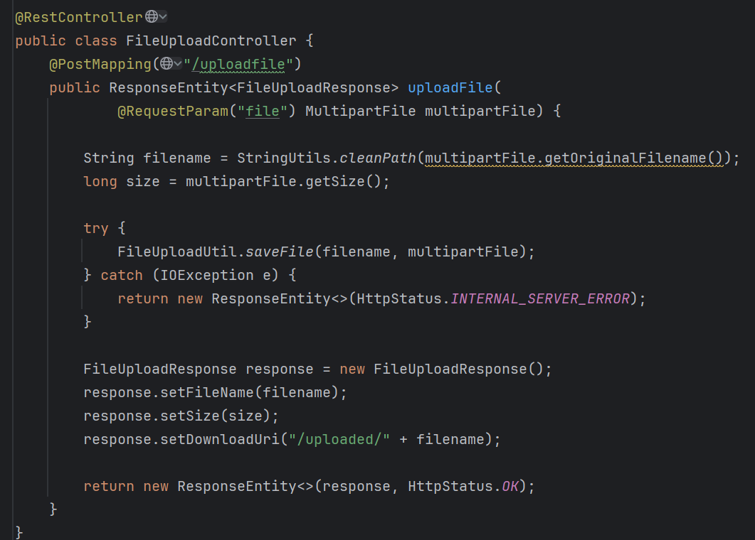
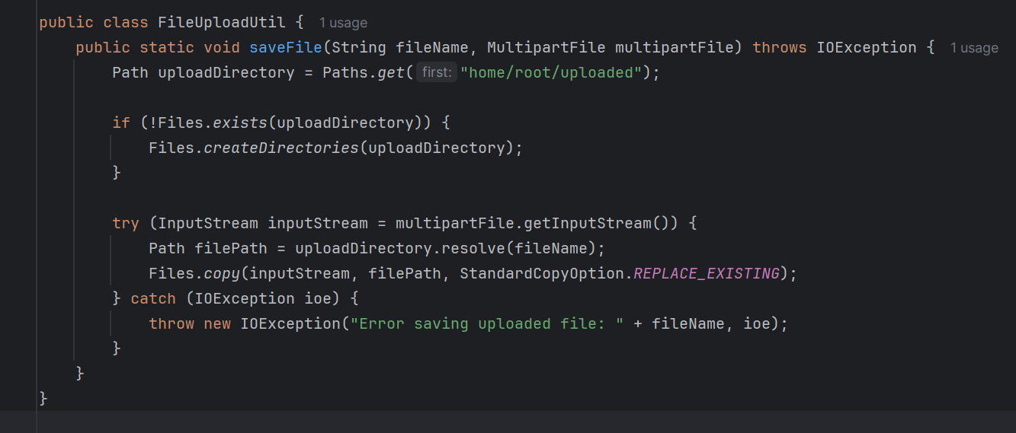
Here I created the directroy on the server.
